# Report on queueing

## Problem

The problem found in the investigation is the significantly large queue lengths and a high average service time of the small, local bank. This causes frustration the customers as it leaves them waiting for long periods of time. After a solution for this problem is found it is expected that the queue length is greatly reduced, and the average service time is diminished to a reasonable time.

## Method

The method used of investigating the queue lengths is at a specific simulation time as the mean service time is always the same, how a change in the mean gap of customers arriving affects the maximum queue length. After the problem is investigated a solution needs to arise for the solution of the issue. The method of reducing the Maximum queue lengths is by lowering the mean service time for each customer. This can be done by either purchasing new equipment that can improve the productivity of the teller, or assigning a second teller that can serve an additional individual at the same time.

## Assumptions

Assumptions made before creating results are that the mean gap of customers arriving is increasing at a constant rate. Moreover, the mean service time is constant after new equipment are implemented or the second teller is placed. Also, we assume that both tellers work at the same service rate and that the queue uses a first in first out (FIFO) layout. Additionally, the simulation time that experiments are carried out is always the same and the time of day has no impact on the results.

## Results

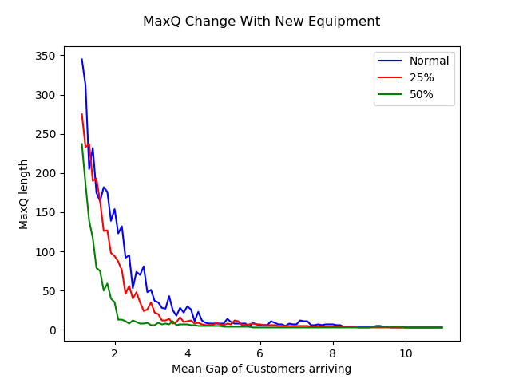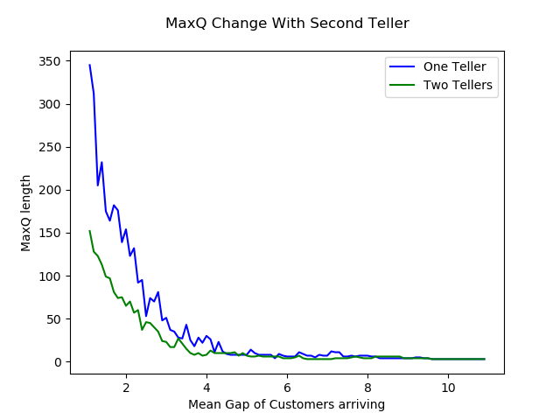

Results show that at a range of percentage reductions for the purchase of new equipment can improve the maximum queue problem but only when the improvement is greater than 25% as that is the point where the investment will be worth. Additionally, adding a second teller has a significant improvement to the queue length at a small mean gap of the customers arriving, but as that gap increases above a certain value of 4 the results show no important improvement.

## Conclusions

The problem was successfully solved using the given methods as queue lengths improved on both cases. A limitation found is that theoretically placing a second teller and having new equipment of a 50% improvement would have had the same impact to the queue lengths. On the other hand, it is shown that they differ, in fact at a small man gap of customers arriving the two tellers have a larger improvement than the new equipment, but as the mean gap increases the new equipment are more productive thus decreasing the queue faster. Also after a mean gap of (5) customers arriving none of the two methods used have an improvement worth implementing. A limitation to the solution of the problem is that it does not take account the time of day where the experiments are carried out and also does not include the human factor affecting the results such as the mean service time changing from human reasons like fatigue. Potential future extensions that can carry out a more accurate solution to the long queue length problem is by carrying out experiments measuring the average queue length throughout the simulation time as the number of customers arriving are increasing.